Walk 19 Fownhope and Common Hill
Last walked in August 2019

Description. A 6 km (3.7 mile) moderate walk with three short sharp climbs. Scenic viewpoints and thru a nature reserve.
Start. Fownhope recreation field off Capler Lane. Explorer Map 189 Grid 579343.
Directions from the Fire Station. (Turn milometer to zero). 200 yards passed the Fire Station TR signed 'Fownhope B4224'. Continue on to the end of Fownhope and at 6.1 miles you TR at St Mary’s Church and go along Capler Lane. After a couple of hundred yards, (6.2 miles) a small white road sign points to the ‘Recreation Field and Parking River Wye’, TR here and go along a narrow lane to the car parking area at the Recreation Field.

1. Car Park. Return to Capler Lane and TL, go back along Capler Lane to the road junction by St Mary’s Church. Go straight across the main road into Common Hill Lane. Proceed along the lane and on your L you pass Canon House, Church Croft road and then Fownhope Medical Centre. Continue on for 150 metres and when the road bends to the R, you TL and go thru a small wooden gate into an arable field F1. TR, follow the field edge (hedge on your R) which, at about 60m bends L. Continue along the field edge for about 100 meters and TR at the hedge corner, into F2. Walk up to the top of the field (fence/tree line is on your R) and cross over a stile onto a gravel driveway. Go across the driveway and continue up hill, to go thru a stile gap and onto a dirt lane (Green Lane), where you TL. Walk along the green lane and after about 40 meters fork R up hill. Continue up the track to TR at a T junction that’s by a telegraph pole (ignore any small tracks off to the R). Continue up a steeper track to another T Junction by a way marked post. TL to go along a well defined track which is part of the Wye Valley Walk.

2. Wye Valley Walk. Continue along the track, passing a cottage on your R. The track is now wide and stony as you continue downhill to a main road (Woolhope road). Cross the road, and then walk on to cross a concrete bridge over a stream. TR and veer to the L as you go thru a gate and up an enclosed track into F3. Continue up the track to reach the end of the wooded area on your R, just by a marker post. Keeping in the same direction go straight across this field to reach a metal gate at the end of the field. Do not go thru the gate but TR and follow the L edge of the field down, to cross a stiled footbridge over a stream and into F4. Go slightly L up this field to cross a stile onto a well defined track/bridleway, (the track goes around the perimeter of Haugh Woods).

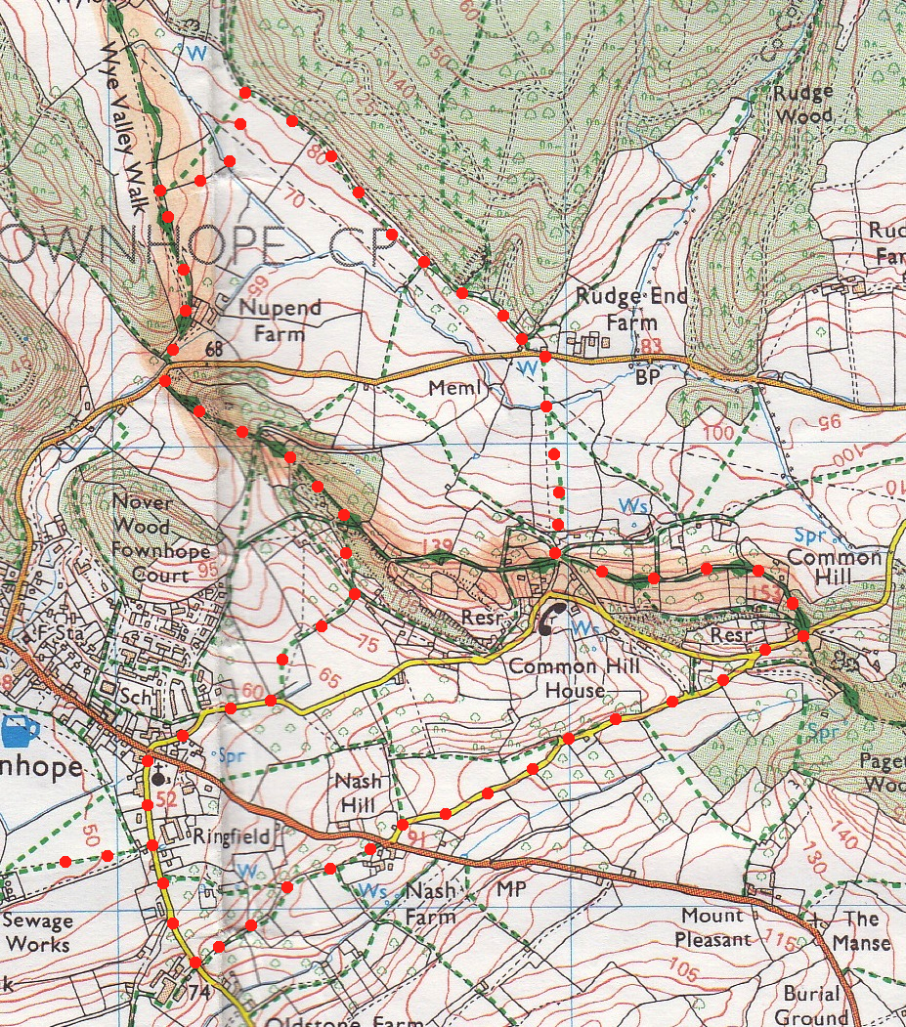
3. Haugh Wood. TR, follow the excellent bridleway for about 1km back to a main road. If you want to make a slight detour to visit Tom Spring’s Memorial, TR and go along the road for about 30 meters then TL thru a gate and the memorial is about 100 metres in front of you. Return to continue the walk. Tom Spring would become the champion bare knuckle fighter of all England. Perhaps his most famous fight was against John Langan, the Irish champion, who he beat after 77 rounds. TL and walk along the road for about 20 meters to TR and go thru a small metal gate into F5, opposite a black and cream cottage called Rudge End. Go straight across the field to go thru a field gap and over a brook into F6. Go straight up this field to go thru a small wooden gate at the top, (the gate is to the R of a house on the hill). Bear R and after a few paces go thru another small wooden gate, then TL to go up a track to emerge at ‘Five Ways’, (five tracks, one of which is a tarmaced).
3
4. Five Ways. There are two enclosed tracks directly in front of you, take the track on the L which starts going up hill. Continue climbing for 200 metres to cross a bridleway gate/stile on your R to pass into Common Hill Nature Reserve. Turn half R and climb the hill, then climb some steps to sit at the viewpoint on Monument Hill, (not that you can see anything). Go thru the gate on your L and TL, continue up and along the ridge to go thru the next small wooden gate. Continue along the track for a short while, and opposite a house on your L you veer R, up a slope to go thru a small wooden gate and onto a track. TL to follow the track down to the main road, (Hawkers Lane).

5. Hawkers Lane. TR to follow the quiet lane downwards for about 1½ km, (ignore a R fork into Common Hill Lane) and reach a main road. Cross the road diagonally R and go thru a metal gate, following public footpath as it bends L and goes thru a farmyard, and continues along the side of a bricked wall (L), to find a detached stile which is near the end of the wall. Continue in the same direction i.e. TL walk 10 paces then TR, and follow the upper R edge of the field, and after about 70 metres you cross a stile into F7, there are solar panels in this field. Continue in the same direction, along the R field edge, and in the field corner you cross over a stile into F8, (ignore the first stile that’s on your R). Continue in the same direction, keeping to the R field edge to cross over a stile onto the main road (Capler Lane) opposite Tump Farm. TR, walk along the lane past the 30mph signs and for a few hundred meters when you TL for the recreation field and the car park.
1
2
5
4

